**Purple Designs for web.**

Web design makes use of this purple power for creating designs with a huge engaging potential, and driving people in. *Purple designs are always extravagant, creative, sophisticated*. Purple is a sure-fire choice for:

* luxury look
* premium quality services
* beauty products

It’s a known fact that purple is traditionally considered a **feminine color**. It strongly appeals to women, and that’s why it’s is the right choice for marketing messages of beauty and fashion websites. It’s especially good for promoting anti-age products in cosmetology. Pre-adolescent children like this color, so as **18-25 year-olds**. The latter see it as extremely sexy and rebellious. That's the reason for its wide usage in websites for night clubs.

Purple is among the least favorite colors by men. At the same time, they give a positive feedback to dark purple.

<https://stablewp.com/>

<http://www.impossible-bureau.com/>

<https://www.kaleidoscopeapp.com/>

<https://wideeye.co/>

Interesting facts about purple:

* **Carrots used to be purple, now most are orange!**

There are many theories as to how and why most carrots are now orange. As far as we can tell, the Dutch have something to do with it. As the story goes 17th century Dutch farmers started to cross-breed specifically for orange carrots in honor of their ruler, William of Orange. Read more [here](http://www.treehugger.com/lawn-garden/why-carrots-are-orange-and-5-non-orange-carrots-grow-your-garden.html).

* **Porphyrophobia is fear of the color purple.**

Say what? We can't imagine someone being fearful of the color purple, however, fearing purple is a real thing! As explained on [phobiasource.com](http://www.phobiasource.com/porphyrophobia-fear-of-the-color-purple/), "the fear of virtually any color is linked to negative associations. The fear can develop as a result of observation or personal experience, but it often goes back to either a conscious or subconscious, but highly negative association between the color purple and something that left a lasting negative impression."

* **Purple Day is celebrated on March 26.**

[Purple Day](http://www.purpleday.org/) was founded in 2008, by Cassidy Megan of Nova Scotia, Canada. Purple Day is celebrated on March 26 and was created to raise awareness for epilepsy. "I wanted people around the world to come together and teach others about epilepsy."

* **There ARE words that rhyme with 'purple'.**

• [curple](http://www.merriam-webster.com/dictionary/curple) (Merriam-Webster)

• [hirple](http://www.merriam-webster.com/dictionary/hirple) (Merriam-Webster)

• [turple](http://www.urbandictionary.com/define.php?term=Turple) (Urban Dictionary)

• [nurple](http://www.urbandictionary.com/define.php?term=Nurple) (Urban Dictionary)

* **There is only one nation with purple in its flag; Dominica.**

Most flags have colors like red, blue, white, black or green. There is however one nation whose flag has purple in it and that's Dominica. [Their flag displays a parrot with purple chest and head](https://www.google.com/search?q=dominica+flag&espv=2&biw=1440&bih=679&source=lnms&tbm=isch&sa=X&ved=0CAYQ_AUoAWoVChMIncyIrNCDxwIVk_WACh0bLAas).

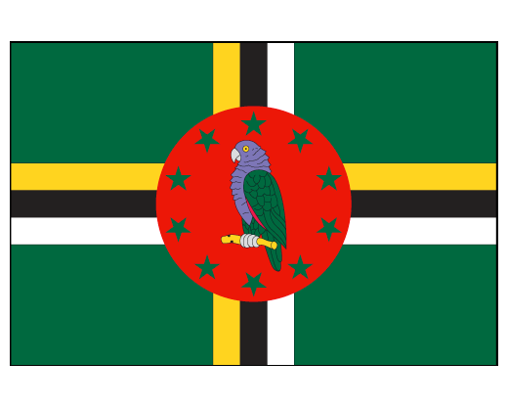

* **Violet, or purple, eyes are extremely rare.**

You might have seen celebrities with violet, or purple eyes. Most of those people are wearing purple contact lenses - to be noticed and look different and to be remembered. Violet eyes are very rare; only (some) people with Albinism or [Alexandria's Genesis](http://www.eyedoctorguide.com/Eye-Color/violet-eye-color.html) may have that color eyes.